SUSTAINABLE SMART CITY

Team Members:

S. Jeevidha (Team Leader)

N. Kanimozhi

c. Sangeetha

s. Kalpana

Abstract:

This project, *Smart City – Eco Assistant & Policy Analyzer*, is designed to promote sustainability and policy awareness using Artificial Intelligence. It leverages natural language processing (NLP) models to generate eco-friendly lifestyle tips and to summarize lengthy government policies. Built with **Transformers, Py Torch, and GRADIO**, it provides an interactive user interface where citizens can:

1. Generate practical solutions for environmental challenges (e.g., water conservation, renewable energy, waste reduction).
2. Upload or paste policy documents to obtain simplified summaries and key points for better understanding.

This solution helps build smarter, greener cities by empowering citizens with actionable knowledge and awareness.

Introduction

* Smart cities aim to improve urban life through sustainability, technology, and efficiency.

* Citizens often struggle to adopt eco-friendly habits and to understand lengthy government policies.

* This project integrates **AI and NLP** to bridge the gap by offering **sustainable living guidance** and **policy summarization** in a user-friendly way.

Objectives

* Provide personalized **eco-friendly tips** for citizens.
* Simplify **policy documents** by summarizing key points.
* Build an **interactive interface** for easy access.
* Support **sustainable smart city initiatives**.

System Design

**Architecture Diagram (you can draw a block diagram like below):**

**User Input → GRADIO Interface → NLP Model (IBM Granite) → Output (Eco Tips / Policy Summary)**

**Modules:**

1. **Eco Tips Generator**
   * Input: environmental problem keywords.
   * Output: actionable sustainability tips.
2. **Policy Summarization**
   * Input: PDF upload or text paste.
   * Process: extract text → summarize with NLP model.
   * Output: simplified summary.

Implementation

**Architecture Diagram (you can draw a block diagram like below):**

**User Input → GRADIO Interface → NLP Model (IBM Granite) → Output (Eco Tips / Policy Summary)**

**Modules:**

1. **Eco Tips Generator**
   * Input: environmental problem keywords.
   * Output: actionable sustainability tips.
2. **Policy Summarization**
   * Input: PDF upload or text paste.
   * Process: extract text → summarize with NLP model.
   * Output: simplified summary.

**Results**

* Users can input **keywords** like “plastic waste” or “solar energy” to get practical eco-friendly solutions.
* Policy PDFs are **summarized** into key provisions, making them easier to understand.
* GRADIO app provides **two separate tabs**: Eco Tips Generator and Policy Summarizer.

**Conclusion & Future Work**

The project demonstrates how AI can support **sustainable smart city development** by educating and empowering citizens.

**Future Enhancements:**

* Support for **multiple languages** (Tamil, Hindi, etc.).
* Integration with **mobile app / chatbot**.
* Real-time government policy updates.
* Recommendation system based on location-specific problems.

**References**

* Hugging Face Transformers Documentation

* IBM Granite Model: Hugging Face Hub

* PyPDF2 Documentation

* GRADIO Documentation

**Screenshot:**

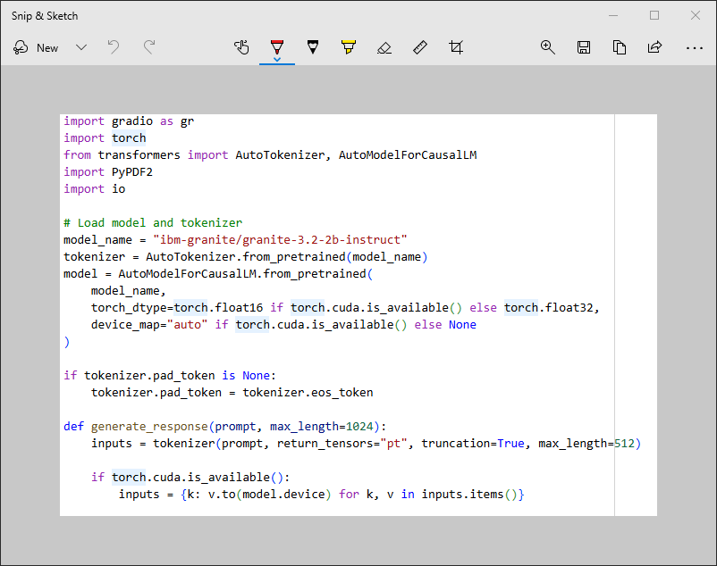



These are the codes we used in this project.

**OUTPUT:**

